## Merchant: *Aquabyte*

Demo date: Mar 25, 2025  
Scoping start date: n/a

MSA Signature Date: Mar 26, 2025  
Onboarding Kick Off Date: Mar 28, 2025

[If Exists] Opt Out Date: none  
Go Live Date: Nov 14, 2024

GTM POC: Jarrett  
Implementation POC: Jeff

ERP: NS

Tax Integration: No Tax

### 

### Key people at Merchant

### Accountant:

### CFO:

### Customer service rep who is really involved:

* Account Receivable POC: Harley Pasternak (
* Billing POC

### Etc.

### 

| Notes Sections [Ops International Team to Ignore] *(AE/ Implementation to fill)*   * Info on how merchant bills   + Internal system tracks services/tests, triggers API to Stripe for invoicing   + Some customers pay via Stripe, others via Bill.com or directly to bank   + Invoices are itemized and long (~10 pages), and customers often request invoice edits Stripe creates invoices, but clients can’t edit them Tabs will allow for cleaner, customizable invoicing * Is there any important merchant relationship information?  1) What is the merchant temperament?   Collaborative, eager to move quickly. SFP is trying to streamline operations for Light Labs and sees Tabs as a strategic partner. 2) Is there a key POC: (i.e.: who is the buyer/decision maker?)  SFP is the partner, Light Labs is their client.  3) What are the Tabs features that the key POC cares about? |
| --- |

### 

### Company summary *(AE to fill)*

Summary of what company does:

Goals (North star)  
*(AE/ Implementation to fill)*

What is the merchant's goal? What pain are we solving? Why are they buying Tabs?

Is there an opt out clause? If so, what is the merchant looking for so they do not exercise it?

### Billing model *(AE/ Implementation to fill)*

* Are there unique things about the customer creation process for this merchant?
* Information on how merchant bills
* How contract is broken up
* One off things to know about the merchant

### Contract Processing Steps *(Implementation/Success to fill)*

1. Steps to process

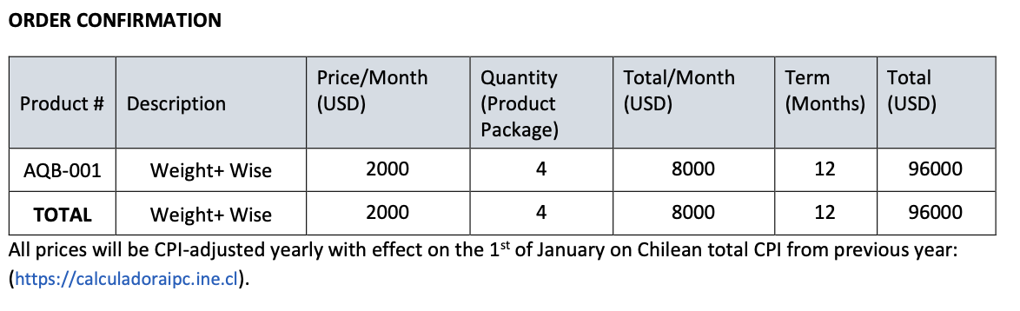

1. Service Start Date: Use the date the product package is delivered
   1. If no specific date is mentioned, use the last signature date
2. Months of Service: Match the duration listed in the “Term (Months)” field in the contract
3. Item Name: Use the name shown in the “Product #” field
4. Item Description: Use the name shown in the “Description” field
5. Integration Item: Based on **billing frequency** (inferred from context or frequency of payment). Typically monthly subscription -
   1. **Monthly billing**: Use Monthly Subscription
   2. **Quarterly billing**: Use Quarterly Subscription
   3. **Annual billing**: Use Annual Subscription  
      If no frequency is explicitly mentioned, assume **Monthly Subscription**.
6. Billing Type: Flat
7. Quantity: Use the figure shown in the “Quantity (Product Package)” column
8. Billing Start Date: Use the date the product package is delivered if explicitly mentioned, otherwise use the service start date
9. Periods and Frequency: Use the number in “Term (Months)” for period if it is a monthly subscription. If stated otherwise (e.g. quarterly/annual), use that term
10. Billing Timing: Bill First of Period
11. Anything to ignore in contracts?
12. Specifics processing things the merchant has requested that may differ by contract (e.g. always back-date invoice date to final day of the month)
13. Default Service Term
    1. If None Listed, Ops Default is 1 Year (12 months)
14. Default Net Payment Terms
    1. If None, Ops Default is 30
15. Default Billing Frequency
    1. If None Listed, Ops Default is Monthly
16. How do we handle taxes as a line item?
    1. If None Listed, Ops Default is every tax line item becomes a BT

### Events Processing (if necessary) *(Implementation/Success to fill)*

* Any important information on events billing

Check for implementation fees (usually explicitly stated on U.S. contracts) - these should be billed when the implementation is complete, with a 30 day net payment term

Integration Items Processing (if necessary)  
*(Implementation/Success to fill)*

* What are the instructions for assigning integration items?
* Example: All Statsig integrations items should be labeled as “Sales”
* Example: All “Pinata” integration items should be labeled as “Software Subscription Bundle” unless otherwise noted by Merchant

Post Processing Communications (if necessary)  
*(Implementation/Success to fill)*

* Does the Ops Team need to notify anyone on the team re: completion of processing batches in Implementation or Active phase?
* Who needs to be notified and when?
  + Example:
    - Who: Customer Success [Azmat Aziz] needs to be notified
    - Where: Messari internal merchant channel
    - When: contracts are processed [Merchant Phase: Active]

### Customer Information *(Implementation/Success to fill)*

* Any important information on specifics customers of this merchant
  + Special memo’s certain invoices require
  + Invoice changes due to merchant/customer relationship

### Feature Requests *(AE/Implementation/Success to fill)*

* FR 1
  + What is it
  + Why it's important
  + Urgency

### Rewatch Calls *(AE/Implementation/Success to fill)*

* Rewatch by dates